LZWS-200型无线（全数字）粮情测控系统
使 用 手 册
Service Manual of LZWS-200 Type Wireless (Full-Digital)
Measurement and Control System for Grain Situation

廊坊市中谷粮保设备有限公司
Langfang Zhonggu Grain Protection Equipment Co., Ltd.

公司宗旨
以质量求生存，以信誉求发展，是我公司一贯的宗旨。公司对产品的生产全过程进行全面质量控制，从选用工业级元器件到半成品、成品的检验测试实行严格把关。多年来以先进的技术，优质的服务赢得了客户的赞誉。
To ensure organizational survival through assured quality and maintain constant growing through reputation is always the tenet of our company. The company controls fully the quality of the whole process of product manufacturing, strictly monitoring through the choosing of industrial grade components to the test and detection of semi-finished products and finished products. For many years, the company has won the customer recognition through advanced technology and excellent service.

目 录

1、概述···················································3
2、系统的特点及主要指标·································3-4
3、系统的硬件···········································4-7
4、系统的规划、安装及软件的使用·························8-9
5、测温电缆结构图········································10
6、附：粮情测控开放式软件平台简介·····················11-12
7、LZWS-200型无线全数字粮情测控系统设备设计安装参考
示意图封面·······································13
8、房式粮仓设计方案······································14
9、房式粮仓结构图····································15-18
10、立筒粮仓结构图····································19-20
11、Summary··············································21
12、System Character·····································21
13、General Index of System······························22
14、Composition List of System Hardware··················23
15、Specification and Installation of System and
Software Application····························24-25
16、Temperature Measurement Cable Construction Chart·····26
17、Add: Grain Condition Test Control Open Software Platform
Brief Introduction································27-28
18、Horizontal Bin Design Plan··························29

1、概述
WXCW-200型无线数字粮情测控系统采用无线网络技术、单片机技术和计算机数字处理技术，对粮食储备库中的粮食保管资料建立数据库，通过美国DALLAS公司生产的数字传感器18B20对粮食温度的采集，上传至计算机显示和打印温度信息及变化曲线。传输方式为无线通信，粮仓与主控机房之间的最远距离不低于2千米。
本系统采用工业级元器件组装，经过检验测试能在环境温度 -30ºC--60ºC 范围内工作，已在多个粮食储备库中使用，效果良好；采取灵活的设计方案，可根据不同规模，不同仓型及用户要求进行配置。
2、系统的特点
2.1 粮情检测的特点
（1）可检测温度(粮温、仓温、外温)和湿度（仓湿、外湿）。
（2）采用数字传感器，误差小，稳定度高，不存在传输误差。
2.2 粮情分析的特点
可把采集的数据储存在计算机内，日后可重新显示、打印，根据历史数据生成温度变化曲线及温度差值，供粮食保管员分析使用。
根据用户需求软件可连接至中国储备粮管理总公司粮情测控管理平台。
2.3 其他特点
（1）系统采用无线传输，布线量小，主控机房可随意选址。
（2）所有电缆采用镀锡芯线，传感器、线路板密闭安装，防腐性能好。
（3）多根测温缆共用一根二芯线，节约测温缆引线。
（4）配电箱内装有时控开关，可延长系统寿命。
（5）适应较宽的环境温度范围，可在我国南北地区使用。
（6）采用单片机控制，配置灵活（可扩展自动通风功能及无线改有线通信）。
（7）采用先进的防雷器件，性能良好。
3、系统的主要指标
3.1 使用的环境条件
（1）温湿度条件
环境温度：-30ºC--60ºC
环境湿度：15%--95%RH
（2）供电条件：交流220V±15% 50HZ±2HZ
3.2．主要技术指标
（1）系统的功能：数据采集、定时采集、输出报表、粮情分析、设置基本信息
（2）系统带载能力：
·每个主机最多带载50个分机（传输终端）。
·每个分机最多带载128个前置机（采集终端）。
·每个前置机最多检测2X36个粮温点。
（3）通信距离：计算机与主机之间 <3米
主机与分机之间 <2000米
分机与前置机之间 <800米
(4)检测速度: 1前置机/3秒
(5)温度检测范围: -30ºC--60ºC
(6)温度检测误差: ±0.5ºC
(7)温度检测分辨率: 0.1ºC
(8)温度检测重复误差: ±0.2ºC
(9)湿度检测范围: 15%--95%RH
(10)湿度检测误差: ±4.5%RH
(11)湿度检测分辨率: 0.5%RH
(12)湿度检测重复误差: ±1%RH
(13)日连续工作时间: 24小时
4、系统的硬件
4.1 系统硬件组成（表一）
4.2 系统硬件间的关系
计算机通过串口控制主机，主机通过无线模块控制多个分机，分机用通信电缆控制多个前置机及温湿度模块，前置机通过测温缆引线与插入粮堆的测温缆连接，测温缆内装有温度传感器(图一、图二)。

表一 系统硬件组成
名称 | 规格 | 数量 | 备注
计算机 | PII/800/128M/1G以上 | 1台 | 用户自备
打印机 | 宽行 | 1台 | 用户自备
测控主机 | WX201 | 1台
测控分机 | WX203 | 按需确定
前置机 | WX202 | 按需确定
温湿度模块 | WX205 | 按需确定
温度传感器 | 18B20 | 按需确定
无线模块 | WX204 | 按需确定 | 每分机配1个
天线 | WX207 | 按需确定 | 每主、分机配1个
电源箱 避雷器 | WX206 | 按需确定 | 每分机配1个
立筒仓测温缆 | WVY32 | 按需确定 | 带加强构件
房式仓测温缆 | WVV | 按需确定
测温缆引线 | WVVP-2芯 | 按需确定
通信电缆 | WVV-4芯 | 按需确定
测温缆转换头 | 塑料铸造 | 按需确定 | 于引线与测温缆间

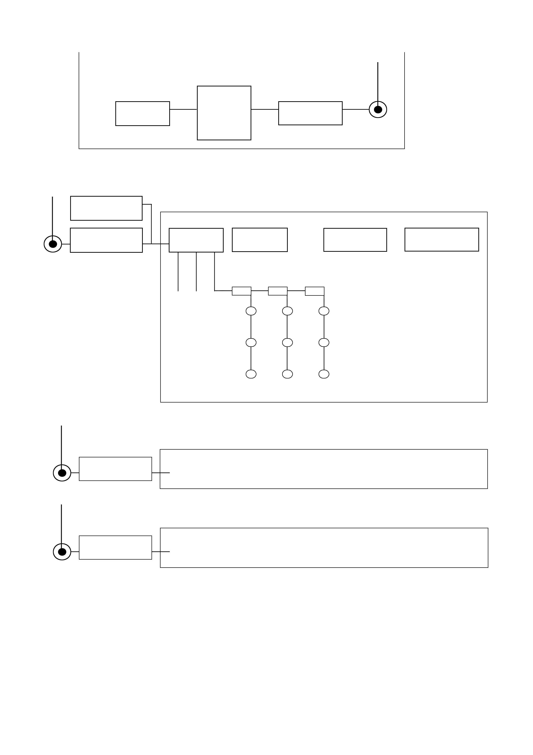

主控机房Master Control Room

计算机
Computer
测控主机
Monitor main machine
打印机Printer

温湿度模块
Humiture Module

前置机1
Front-end processor 1
测控主机Monitor Extension 1
前置机2
Front-end processor 2
前置机N
Front-end processor N
温湿度模块
Humiture Module

粮仓1
Granary 1

测控主机2
Monitor Extension 2

粮仓2 Granary 2

测控分级N
Monitor Extension N

粮仓N Granary N

图一 测控系统的组成及相互关系（房式仓）
Figure 1 Composition and correlation of the measurement and control system (horizontal bin)

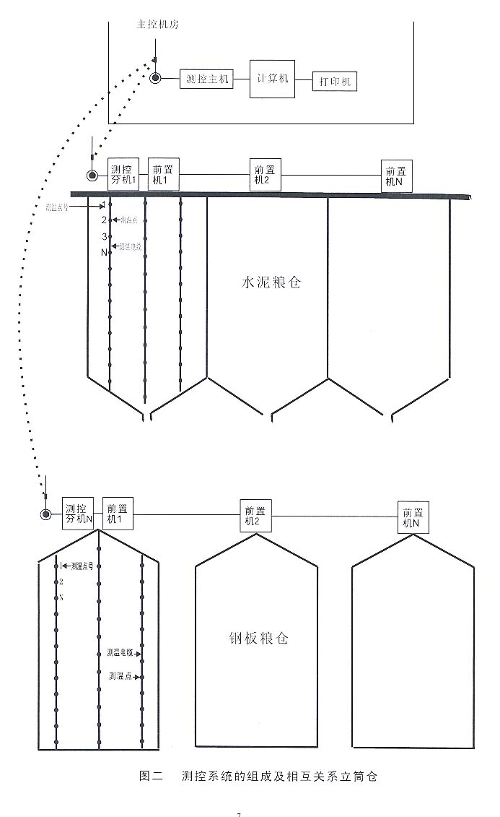
主控机房 Master Control Room

测控主机
Monitor main machine
计算机
Computer
打印机
Printer
水泥粮仓
Cement Granary
钢板粮仓
Steel Silo
测控主机1
Monitor Extension 1

前置机1
Front-end processor 1
前置机2
Front-end processor 2
前置机N
Front-end processor N
测温点号
Temperature measurement point No.
测温点
Temperature measurement point

测温电缆
Temperature measurement cable

测温电缆
Temperature measurement cable

测温点
Temperature measurement point

测温点号
Temperature measurement point No.

测控铸机
Measurement&
Control Extension N

前置机1
Front-end processor 1
前置机2
Front-end processor 2
前置机N
Front-end processor N
图二 测控系统的组成及相互关系立筒仓
Figure 2 Composition and correlation of measurement and control system (vertical silo)
5、系统的规划
使用本系统前要先进行总体规划，包括测温点布局，前置机、温湿度模块和分机用量及安排。
测温点原则上按垂直间隔<2米,水平间隔<5米,距墙0.8-1米分布。
温湿度模块每仓用一个，仓外用一个。
前置机的用量根据仓的大小而定。
分机的使用根据所有仓的地理分布而定，一般是连在一起的仓共用一个分机。
规划一般由厂家技术人员，根据粮库提供的情况进行设计，由粮库认可。
规划完成后，交由各方面人员进行准备：软件设计人员进行软件设计；电缆生产人员生产测温缆；硬件生产人员准备硬件。
6、测温缆的结构（结构图1、2）
7、系统的安装
7.1 计算机与主机的连接
将计算机的“串口1”通过串口线与主机的串口连接器连接。
7.2 分机与前置机、温湿度模块的连接
分机与前置机、温湿度模块通过四芯线连接，通常红接V，黑接G，兰接A，黄接B。
7.3 前置机与测温缆的连接
测温缆的红线接前置机的L，测温缆的黑线接前置机的G。
8、软件的使用
8.1 软件的安装
1、运行setup.exe 程序，遇到错误时点确定，遇到旧文件替换新文件时点保留。
2、将Excels文件夹和无线粮情测控系统.exe文件一起考贝到D盘中。
3、配置ODBC:开始-控制面板-管理工具-数据源（ODBC）-用户DSN里点添加-选Access Driver(*.mdb)后点完成-输入数据源名称LQCK1、选择数据库为D盘里Excels下lqck.mdb,然后以次确定。
4、为了使日期时间排序正确，需要设置一下系统日期时间格式。设置顺序：
开始-控制面板-区域-区域选项里的自定义-将时间日期的格式改为双字母。
8.2 软件的运行
1、双击D盘里的无线粮情测控系统.exe文件出现登录窗口，点确定启动软件。
2、点击基本信息，修改粮库名称和各个仓库信息。
修改方法：选中右边表格里的欲修改的单元格，点修改按钮，在文本框里编辑后点更新。
3、点击粮情检测可进行数据采集和数据分析。
在数据采集前选中（可多选或单选，篮表示选中）要采集的仓名，点击开始采集按钮，完成后点仓名，可观察到表格中的数据。选中要存储的仓名，点击存储数据按钮，可将数据数据存储到数据库中。
在数据分析里，单选仓名，选择时间，可显示数据、输出报表；选择第二时间可显示各点粮温差值；选择两个点位，可输出两个点及均温变化曲线。
输出报表时自动调用Excel,可进行编辑和打印。
点击定时设置可修改设定的时间；在定时生效选中时，时间一到，系统自动采集15分钟后，保存数据。
4、注意事项：
1、在进行输出报表和输出曲线时要将打开的Excel关掉。
2、一边测一边观察测试结果，如有-0.1过两分钟再测，如有空值可立即再测，然后可存储或打印。
3、分机箱内装有电源定时开关，一般调整在8:00-18:00通电。

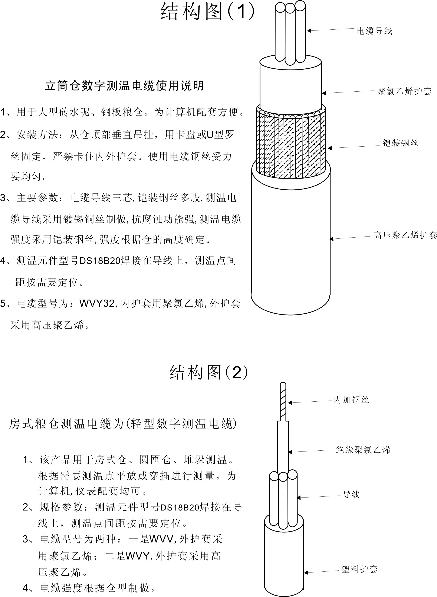

附：粮情测控开放式软件平台简介

为了满足一些用户的特别需要，我公司最近与某大学联合开发了粮情测控开放式软件平台，现介绍如下：

·1.1 关于粮情测控开放式软件平台
粮情测控开放式软件平台是利用现代电子技术来实现粮食储藏过程中对影响粮情变化因素的实时检测、对实时检测数据进行分析与判断、对安全储粮提出处理建议并予以控制的系统。本系统利用现代工控组态思想和中间件技术，组建一个统一可扩充、可重构、可相容的并具有柔性和适应性的粮情测控系统软件平台，在这个软件平台上，可以动态的选择不同的硬件厂家设备，系统平台向各种不同的粮情测控硬件系统发送检测指令，并从这些系统中提取已检测的粮情数据信息，根据信息向硬件系统发出相应的控制信号。从而向上屏蔽各种系统的差异，达到互通互联。
该平台是一个自开发体系结构，实现了系统功能的构件化，用户可以定制所需要的模块。软件平台在屏蔽底层硬件设备相异性的同时，向上层提供了统一标准接口，实现无缝连接。统一的数据格式，统一的界面，统一的传输协议，可以实现信息共享，给管理工作带来很大的方便。
该平台系统支持局域网和广域网功能，能够极大地方便粮库各级领导的查询和统计工作。
在粮库局域网中，该系统主要由测控主机和数据查询客户端组成。测控主机负责检测和控制粮情测控设备，一般由一台计算机负责。数据查询客户端可部署于粮库局域网的多台计算机上，由相关领导和工作人员进行粮情数据的查看、统计及报表绘制等。
本系统还可以工作在总公司粮食专网的广域网环境中，粮库通过配置一台IIS服务的WEB服务器，就可以向异地提供粮情查询。

1.2 平台的主要功能
1）对应具体一个粮库，快速定制出该粮库的检测软件，用户使用简单操作即可进行粮库布局设计等功能；
2）用户身份验证，不同用户具有不同的操作权限；
3）选择硬件设备，进行硬件初始化工作；
4）增加、删除仓房，并设置仓房信息和仓内布点信息；
5）测温、测湿、测虫的粮情实时检测；谷冷、通风、熏蒸的粮情实时控制；
6）以模拟三维立体方式显示粮情，对仓房温度分层、分列显示；
7）以表格、曲线的形式打印输出，每天的粮情数据自动存档，以备历史查询；
8）Web粮情查询分析服务：为中储粮总公司提供远程的粮情立体数据察看，粮情报表打印，粮情温度曲线察看等安全快速高效的广域网web远程服务；
9）粮情测控系统平台客户端服务：可以为局域网内的用户提供远程的粮情数据查询，粮情数据立体显示，粮情报表预览及其打印，粮情曲线查询及其打印等功能；
10）粮情测控系统平台短信服务：提供了远程粮情手机短信查询功能，即根据注册用户的短信指令返回粮情分析数据；
11）为粮库工作人员提供储粮害虫防治信息资源库，以备查询和学习。

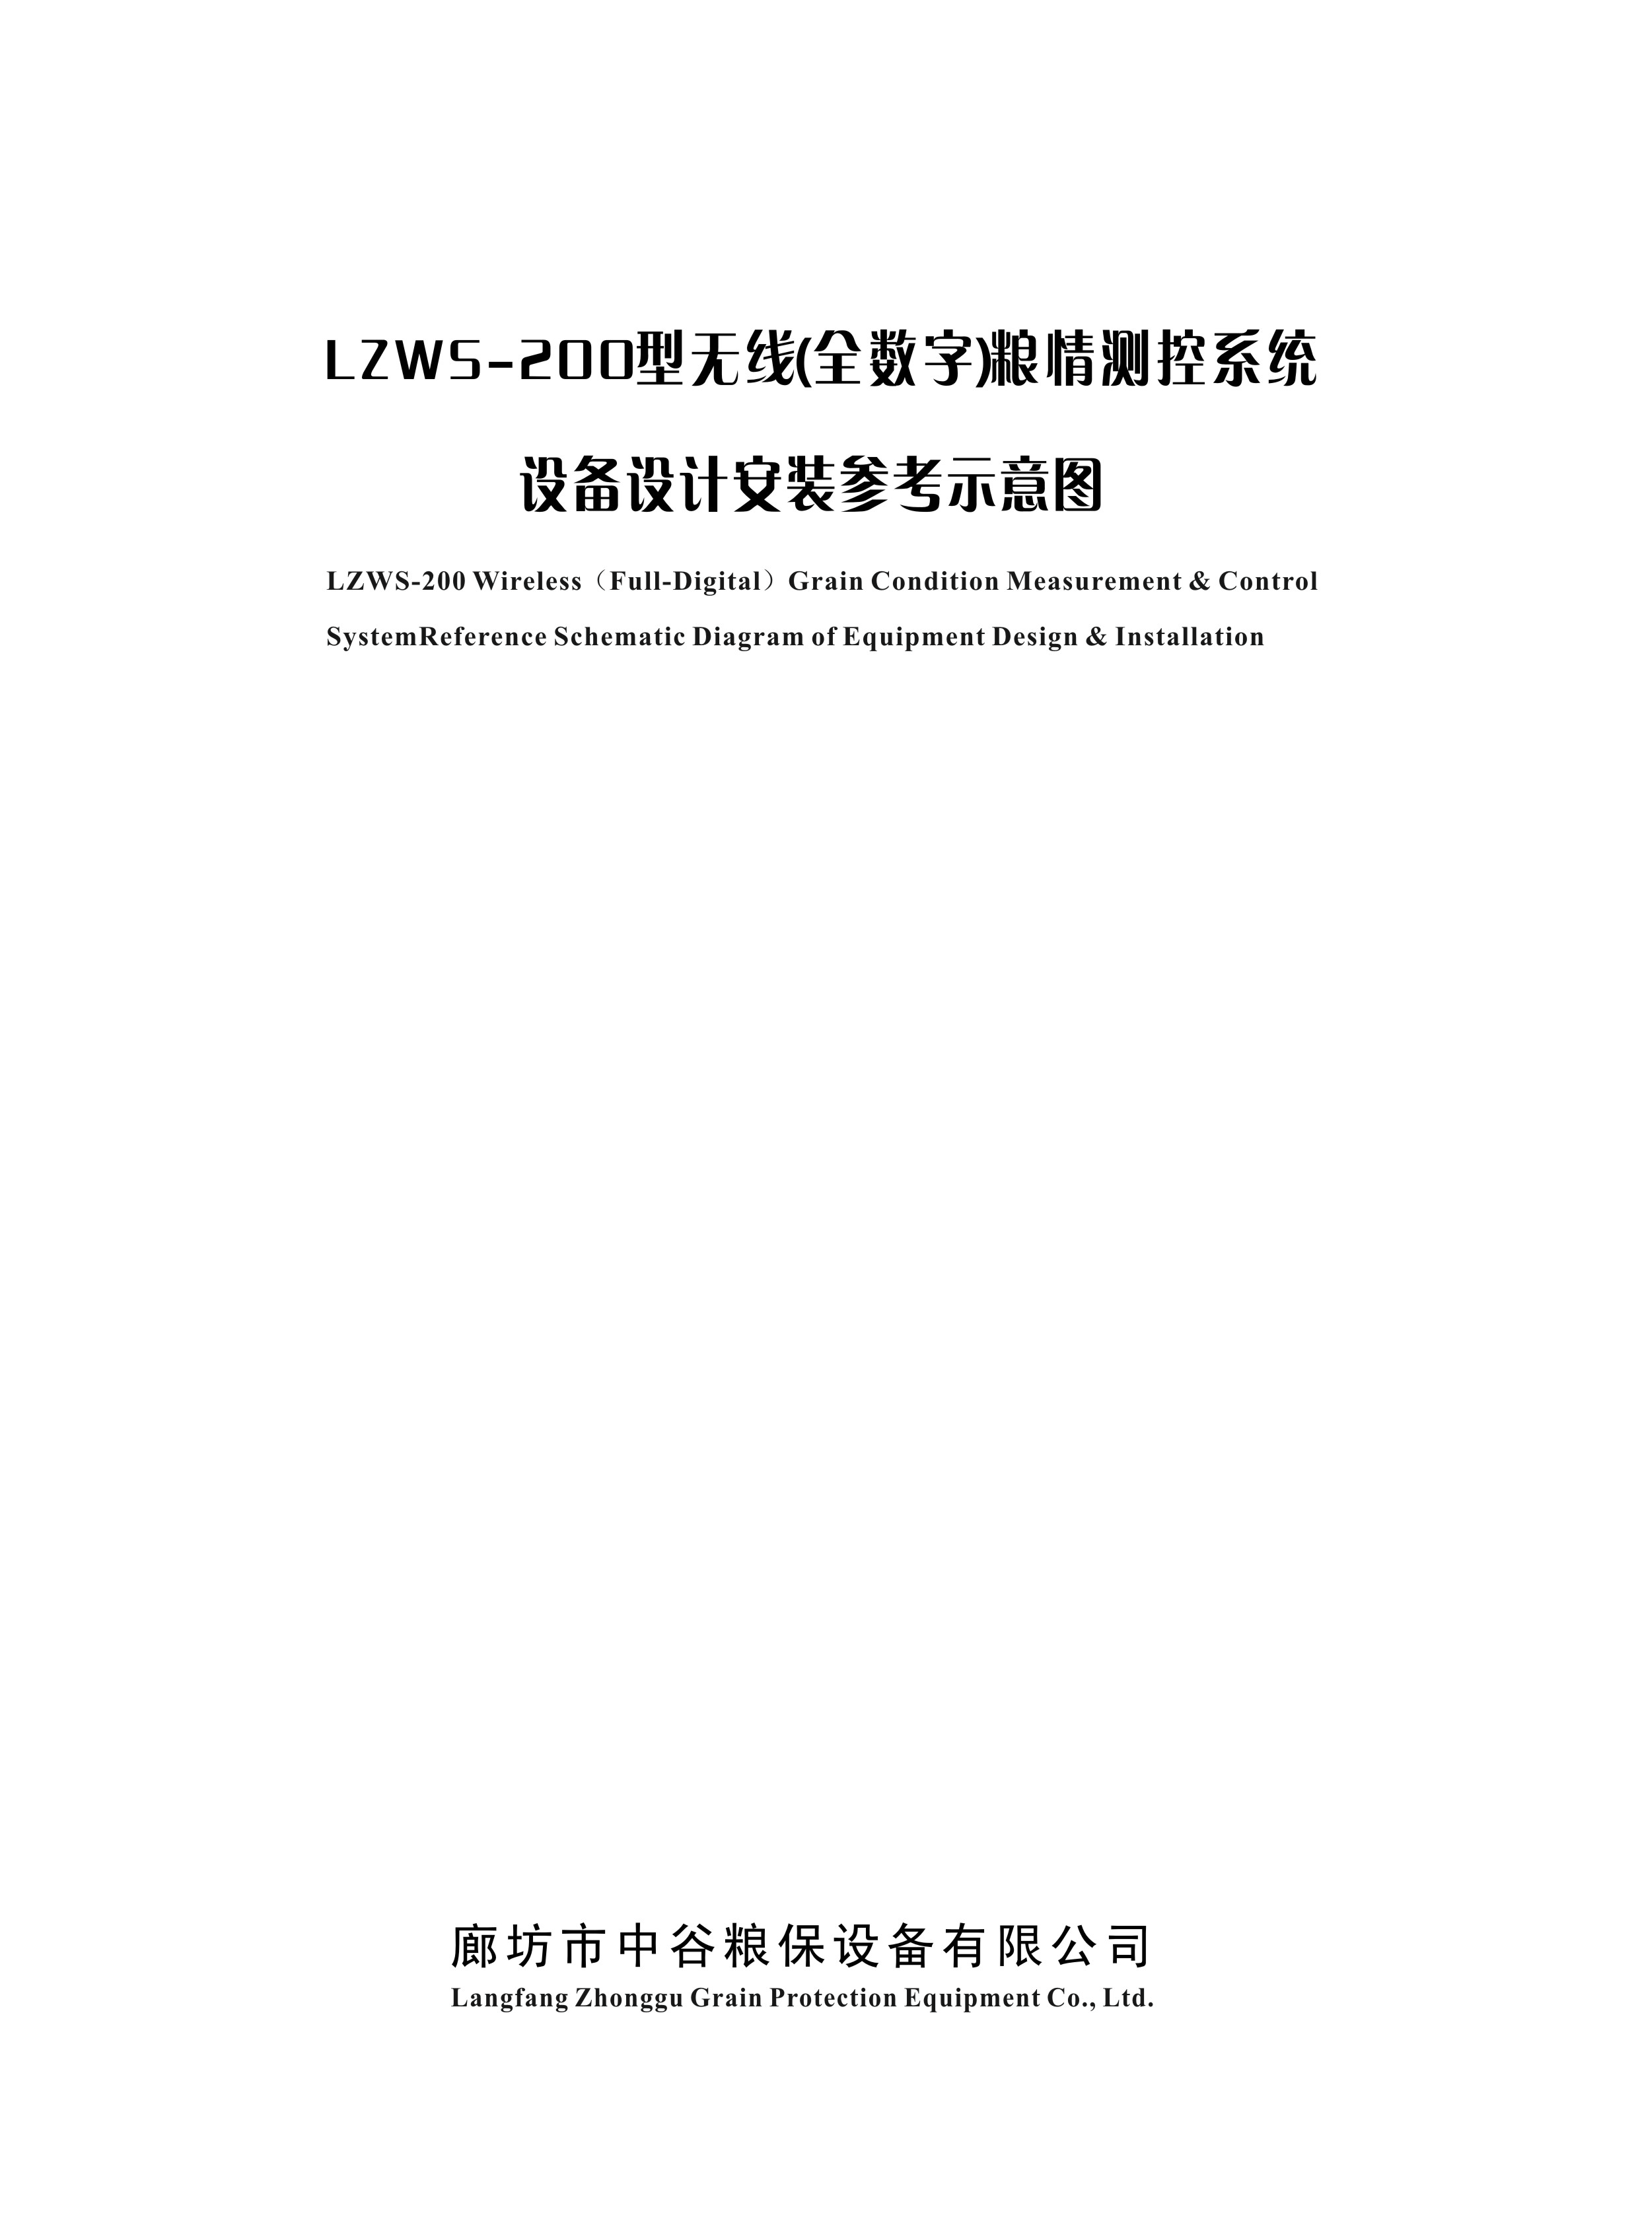

北京牛栏山粮食收储库5栋仓房安装
LZWS-200型无线数字粮情测控系统设计方案

本房式仓的粮情检测系统施工安装参照中直库建设标准，根据2002-05-13发布《中华人民共和国粮食行业标准》LS/1203-2002中的传感器布置原则执行；该系统完全符合国家粮食储备总公司《粮情电子检测分析控制系统技术规程》要求。
具体方案结合附图说明如下：
一、测温设备分布:
A仓4栋，分8个敖间，每个敖间长59.5米，宽29.2米，粮面高6米，每个敖间设测温电缆13组，每组7根，每根电缆设4个测温点，全仓共91根缆，364个测温点。
B仓1栋，仓长41.7米，宽17.7米，粮面高5米，一栋仓设测温电缆10组，每组5根，每根缆设4个测温点，全仓共50根缆，200个测温点。
二、设备分配及安装
一家粮库用测控主机一台，软件一套，A仓一个敖间用分机、电台、配电箱、天线各一个，固定在仓外仓壁上，每个敖间用前置机7个，测仓温、湿度传感器一套，固定在粮仓内的仓壁上，B仓一栋，用分机、电台、配电箱、天线各一个，全仓用前置机4个，测仓温、湿度传感器一套，安装方式同上。
测控主机、天线和计算机放在控制室。
三、缆线连接：测控主机与计算机用485方式连接，主机与分机用无线电台传输，分机与前置机及前置机间用4芯通讯电缆连接。
注：本系统采用的数字温度传感器是美国DALLAS公司生产（型号DS18B20）。
整套设备用全密封方式，能防雷、防熏蒸、防腐蚀等功能。
具体详见图一、图二、图三、图四所示。

廊坊市中谷粮保设备有限公司
二OO七年十二月一日

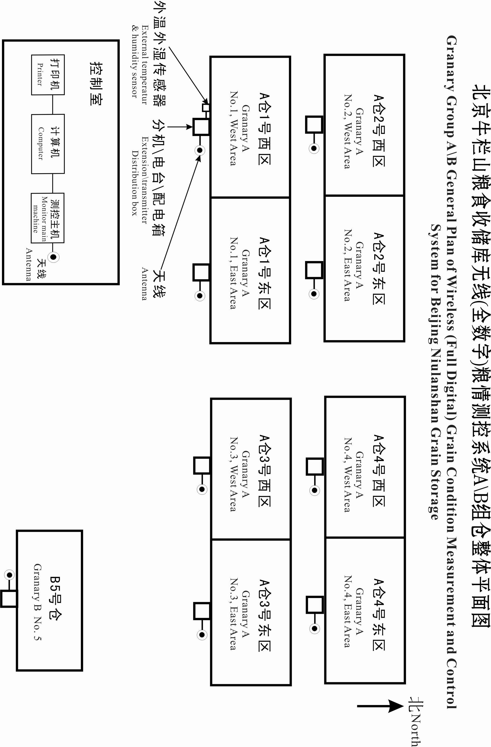

（图一）北京牛栏山粮食收储库无线（全数字）粮情测控系统A组仓平面图
(Fig. 1) Granary Group A Plan of Wireless (Full Digital) Grain Condition Measurement and Control System for Beijing Niulanshan Grain Storage
- A仓4栋分8个敖间，每个敖间长59.5米，宽29.2米，粮面高6米。配置分机、电台、天线各一个，配置前置机7个，每个可带2组缆，测温电缆13组（各组缆之间距离4.88米）
- 每组设7根测温电缆（每根缆设四个测温点），缆间隔4.7米。7
- 测温电缆与墙间距0.5米。
- 每个敖间共计测温电缆91根，364个测温点。

- Granary group A includes 4 granaries, which is further divided into 8 sub-granaries. Each sub-granary is in 59.5m long, 29.2m wide, the grain surface is in 6m high. These sub-granaries are equipped with 1 extension, 1 transmitter, 1 antenna, 7 front-end processors which can run two groups cables, 13 groups temperature measurement cables (the space between each row of cable is 4.88m).
- Each group has 7 temperature measurement cables (each cable has four temperature measurement points), the distance between every two cables is 4.7m.
- The temperature measurement cable is 0.5m away from the wall.
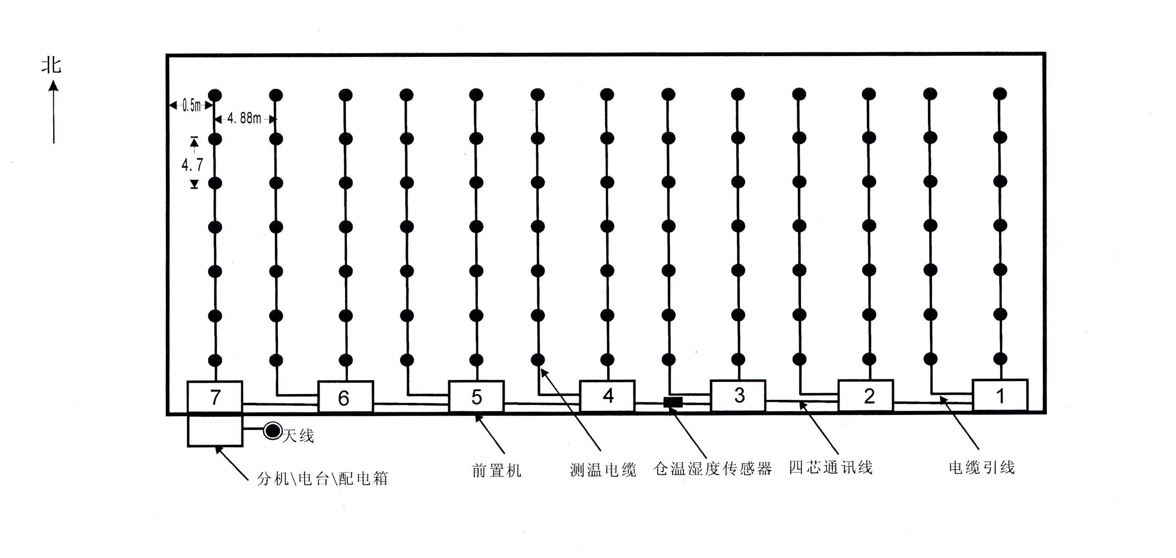
- Each sub-granary has 91 pieces of temperature measurement cables, 364 temperature measurement points in total.
天线 Antenna
分机/电台/配电箱
Extension\
Transmitter\ Distribution Box
前置机
Front-end processor
测温电缆
Temperature measurement cable
仓温湿度传感器
Granary humiture sensor
四芯通讯线
Four-core communication cable
电缆引线Cable-wire
（图二）北京牛栏山粮食收储库无线（全数字）粮情测控系统B组仓平面图
(Fig. 2) Granary Group B Plan of Wireless (Full Digital) Grain Condition Measurement and Control System for Beijing Niulanshan Grain Storage
- B仓1栋仓长41.7米，宽17.7米，粮面高5米。配置分机、电台、天线各一个，配置前置机4个，每个可带3组缆，测温电缆10组（各组缆之间距离4.5米）
- 每组设5根测温电缆（每根缆设四个测温点），缆间隔4.17米。
- 测温电缆与墙间距0.5米。
4. 一栋房仓共计测温电缆50根，200个测温点。

- Granary group B has one granary, which is in 41.7m long, 17.7m wide, and the grain surface is 5m high. This granary is equipped with 1 extension, 1 transmitter, 1 antenna, 4 front-end processors which can run 3 groups cables, 10 groups temperature measurement cables (the space between each row of cable is 4.5m).
- Each group has 5 temperature measurement cables (each cable has four temperature measurement points), the distance between every two cables is 4.17m.
- The temperature measurement cable is 0.5m away from the wall.
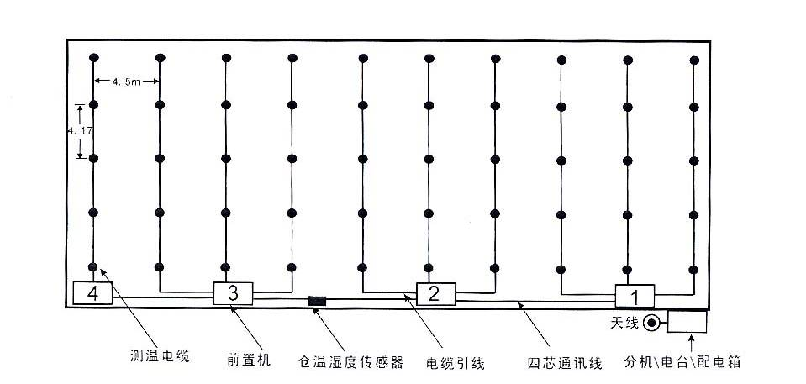
4. There are all together 50 temperature measurement cables and 200 temperature measurement points in total for one granary.
测温电缆
Temperature measurement cable
前置机
Front-end processor
仓温湿度传感器
Granary humiture sensor
电缆引线
Cable-wire
四芯通讯线
Four-core communication
cable

天线Antenna
分机/电台/配电箱
Extension\Transmitter
\Distribution Box

（图三）北京牛栏山粮食收储库无线粮情测控系统剖面图
(Fig. 3) Profiles for wireless Grain Condition Measurement &

Control System of Beijing Niulanshan Granary
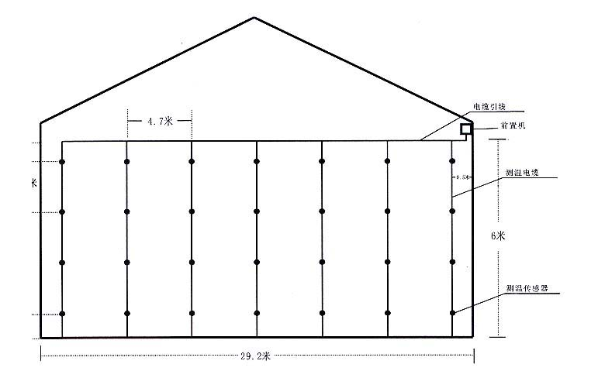
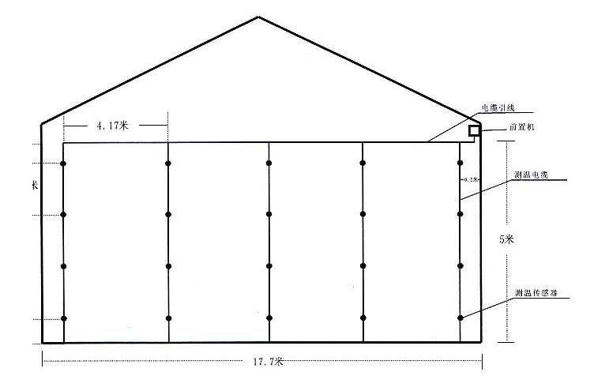
4.7 m
1.7 m
0.5 m
0.4 m
电缆引线 Cable lead-wire
前置机 Front-end processor
sensor
测温电缆
Temperature measurement cable
6 m
29.2 m
0.5 m
4.17 m
0.4 m
1.4 m
0.4 m
17.7 m
温度传感器Temperature measuring sensor

5 m
测温电缆Temperature measurement cable

前置机 Front-end processor

电线引线 Cable lead-wire

0.5 m
(Fig.4)
注明：A仓8个敖间，每个敖间粮仓宽29.2米，粮面高6米。测温电缆每组7根，每根间隔为4.7米，距仓壁0.5米，测温点垂直间隔为1.7米，距粮面0.5米，距地面0.4米。
Remark: Granary A includes 8 sub-granaries. Each sub-granary is in 29.2m width, the grain surface is 6m high, the temperature measurement cables are 7 pieces in one group, the space between two cables are 4.7m; the distance to the granary wall is 0.5m. The vertical space between temperature measurement points is 1.7m, the highest temperature measurement points is 0.5m to the grain surface and the lowest temperature measurement points is 0.4m to the floor surface.
注明：B粮仓宽17.7米，粮面高5米。测温电缆每组5根，每根间隔为4.17米，距仓壁0.5米，测温点垂直间隔为1.4米，距粮面0.4米，距地面0.4米。
Remark: Granary B is in 17.7m width, grain surface is 5m high. The temperature measurement cables are 5 pieces in one group, the space between two cables are 4.17m; the distance to the granary wall is 0.5m. The vertical space between temperature measurement points is 1.4m, the highest temperature measurement points is 0.4m to the grain surface and the lowest temperature measurement points is 0.4m to the floor surface.
秦皇岛正大有限公司粮情测控系统整体平面图
General Layout Plan of Grain Condition Measurement & Control System for Qinhuangdao Zhengda Co., Ltd.
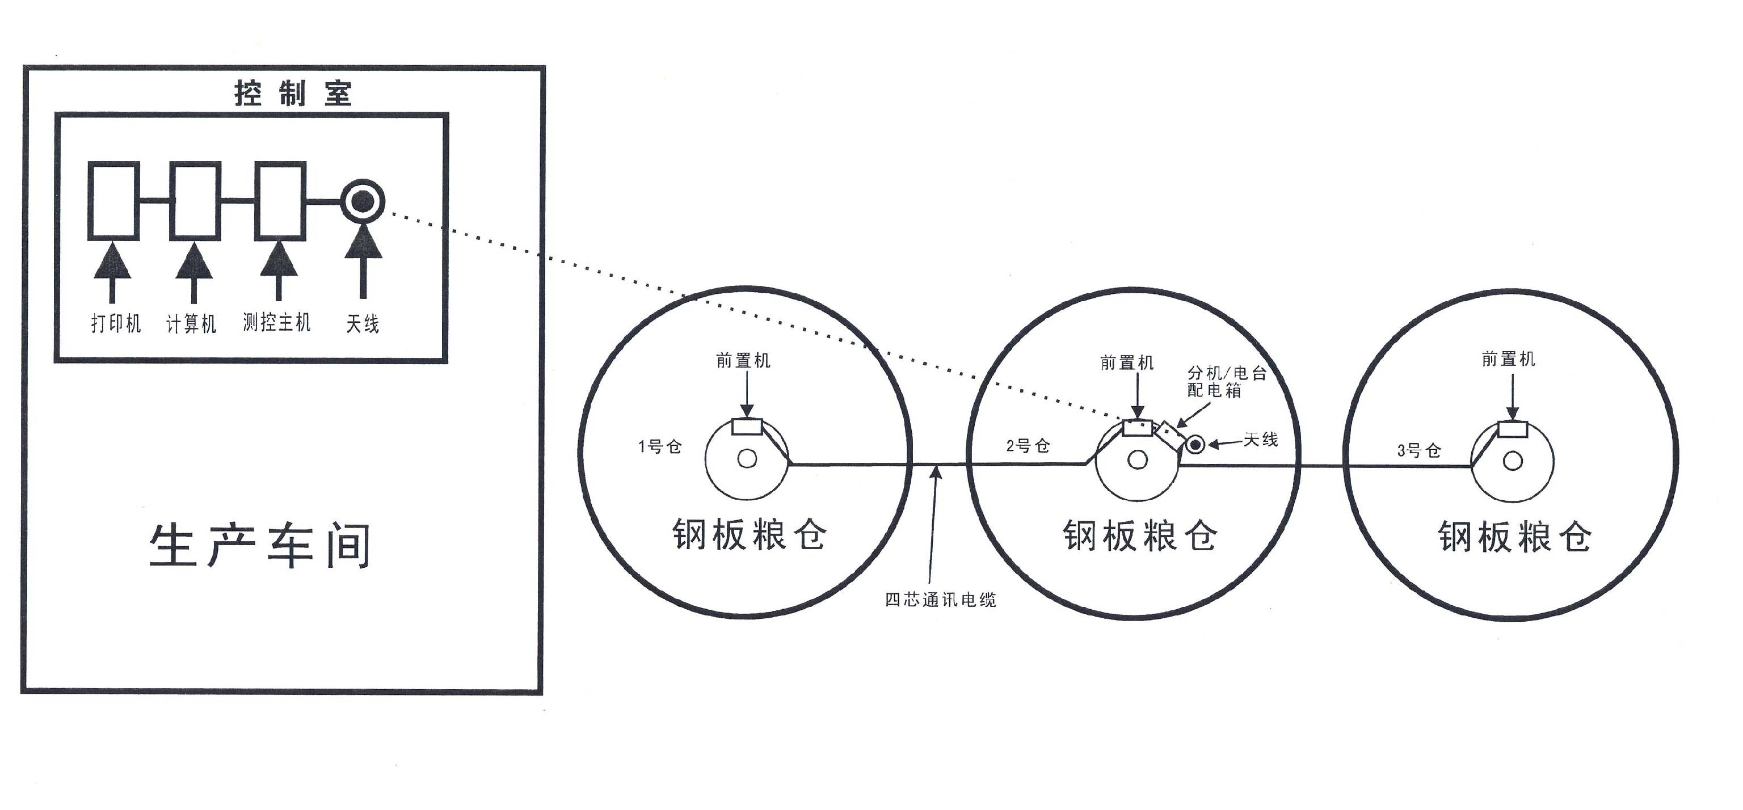
控制室Control Room
打印机 计算机
Printer Computer

生产车间
Production Workshop
测控主机Monitor main machine
天线Antenna
前置机
Front-end processor
1号仓
No.1 Granary
钢板粮仓
Steel silo
4芯通讯电缆
4-core communication cable
钢板粮仓
Steel silo
钢板粮仓
Steel silo
2号仓
No.2 Granary
3号仓
No.3 Granary
前置机
Front-end processor
前置机
Front-end processor
天线Antenna
设备分配及安装：每个仓用前置机3个，3个仓共用分机/电台/配电箱/天线各一个，固定在粮仓边上，测控主机及天线和计算机放在控制室。
缆线连接：测控主机与计算机用485方式连接，主机与分机用无线电台连接，分机与前置机及前置机间用4芯通讯电缆连接。
注：在安装前需方需把200的交流电接到有分机的仓顶上。
Cable connection: the monitor main machine shall be connected with the computer in 485 type, the main machine connects with extension by wireless transmitter, the extension connects with the front-end processor and the space of the front-end processor by 4-core communication cable.
Remark: Before installation, the buyer needs to connect the 220 V AC onto the top of silo with extension.
分机/电台/配电箱
Extension/ Transmitter
Distribution box
North
秦皇岛正大有限公司粮情测控设计及设备安装图
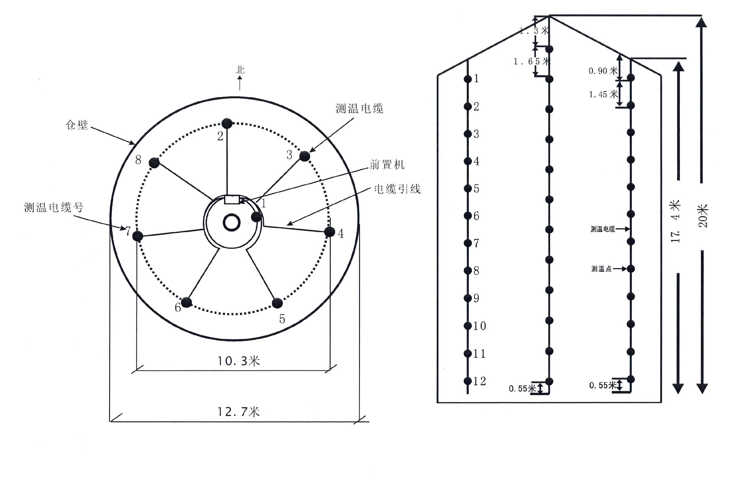
Design and Equipment Installation Drawing of Grain Condition Measurement & Control System for Qinhuangdao Zhengda Co., Ltd.
17.4 m
20 m
仓壁
Silo wall
测温电缆号Temperature measurement Number
北
North
测温电缆Temperature measurement cable
前置机Front-end processor
电缆引线Cable lead-wire
0.55 m
0.55 m
测温点Temperature measurement point
测温电缆Temperature measurement cable
1.45 m
0.90 m
1.65 m
1.3 m

Langfang Zhonggu Grain Protection Equipment Co., Ltd.
Jun. 8th, 2007
钢板藏3栋直径12.7米,高20米内设8根电缆,外圈测温电缆7根,中间一根,每根电缆设12个测温点,电缆测温点垂直间隔外圈1.45米,中间测温点间隔1.65米
There are 3 steel silos, the diameter for each silo is 12.7m and the height is 20m. Each silo has 8 pieces of cables inside, in which, 7 cables are the outer circle temperature measurement cable, and one cable in the middle. Every cable has 12 temperature measurement points, the vertical interval of cable temperature measurement points of the outer circle is 1.45m, and the middle interval of temperature measurement points is 1.65m.
12.7 m
10.3 m
1. General introduction
LZWS-200 Type Wireless (Full-Digital) Measurement and Control System for Grain Situation applies wireless network technology, Mono-chip computer technology and computer digital processing technology to build database for the data of reserved grain in Grain storage silos, collect the grain temperature through digital sensor 18B20 produced by American DALLAS company and upload it to the display of computer and printed temperature information and change curve. The transmission mode is wireless communication and the maximum distance from the granary to the main control machine room is no less than 2 km.
The system applies industrial level components assembling, through inspection and test it can work in the ambient temperature of -30℃-60℃, and it has been used in many granaries and the effect turned out to be good. Flexible design is applied which can configured according to different scale, style of granary and the requirement of customers.
2. Characteristics of system
2.1 Characteristics of measurement and control for grain situation
(1) It can measure the temperature (the temperature of grain, granary and outside) and humidity (the humidity of granary and outside).
(2) It applies digital sensor which has very low difference and high stability and transportation difference dose not exist
2.2 Characteristics of analysis of measurement and control for grain situation
It can store the collected data in the computer, and display and print them in the future. Through history data, it can give temperature change curve and temperature difference value which can be used for analysis of the grain storekeeper.
According to the requirement of customers, the software can be connected with the management platform of management and control for grain situation of China Grain Reserves Corporation.
2.3 Other characteristic
(1) The system applies wireless transportation, the quantity of wire is small, and the main control machine room can be chosen everywhere.
(2) All cables apply tin-coated core wire; the sensor and circuit board are installed in closeness which keeps good anticorrosiveness.
(3) Many temperature measurement cables share one double core wire which saves the lead wire of temperature measurement cable.
(4) Automatic clock switch is installed in the distribution box which prolonged the system life.
(5) It is suitable for large scale of environment temperature and can be applied in the south and north district of out country.
(6) It applies mono-chip computer control and the layout is flexible ( it can be extended to automatic ventilation function and the wireless communication can be replaced by wire communication).
(7) It applies advanced lightning proof devices and the performance is good.
3. Main index of system
3.1 The environment condition of application
(1) Temperature and humidity condition
Environment temperature: -30℃--60℃
Environment humidity：15%--95%RH
3.2 Main technical index
(1) System function: data collection, timing collection, output the report forms, analysis of grain situation, set up basic information
(2) Loading ability of system
·each host can be loaded with 50 subsets at most (transportation terminal )
·each host can be loaded with 128 front-end processors at most (collection terminal)
·each front-end processor can inspect 2×36 grain temperature point
(3) Transportation distance:
Between computer and the host ＜3m
Among hosts ＜2000m
Between host and front-end processor ＜800m
(4) Detection speed: 1 front-end processor/ 3 seconds
(5) Temperature detection scale: -30℃--60℃
(6) Temperature detection difference: ±0.5℃
(7) Temperature detection resolution: 0.1℃
(8) Repeat deference of temperature detection: ±0.2℃
(9) Humidity detection scale: ±15%--95%RH
(10) Humidity detection difference: ±4.5%RH
(11) Humidity detection resolution: 0.5%RH
(12) Repeat deference of humidity detection: ±1%RH
(13) Daily continuous operating time: 24 hours
4. Hardware of system
4.1 Constitution of system hardware (Table 1)
4.2 Relations among system hardware
The computer controls the host through serial port, the host controls several extensions through wireless module, the extension controls many front-end processors and temperature & humidity module with communication cable, and the front-end processor connected with temperature measurement cable plugged in the grain pile through lead wire of temperature measurement cable. There are temperature sensors in the temperature measurement cable. (Fig. 1 and Fig. 2)

Constitution of system hardware (Table 1)
Name | Specification | Quantity | Remarks
Computer | PII/800/128/1G above | 1 | Provided by customer
Printer | Wide line | 1 | Provided by customer
Test Control Main Frame | WX201 | 1
Test Control Extension | WX203 | Confirmed by necessary
Front-end Processor | WX202 | Confirmed by necessary
Humiture module | WX205 | Confirmed by necessary
Temperature Sensor | 18B20 | Confirmed by necessary
Wireless Module | WX204 | Confirmed by necessary | One extension equipped with 1
Wireless | WX207 | Confirmed by necessary | Each mainframe and extension equipped with 1
Power Box  Lightening arrester | WX206 | Confirmed by necessary | Each extension equipped with 1
Vertical silo temperature measurement cable | WVY32 | Confirmed by necessary | Own tension member
House modern barn temperature measurement cable | WVY | Confirmed by necessary
Temperature Measurement Cable Leading Wire | WVVP-2cores | Confirmed by necessary
Communication Cable | WVY-4cores | Confirmed by necessary
Temperature Measurement Cable Transducing Head | Made of plastic | Confirmed by necessary | Between leading wire and temperature measurement cable

5. Planning of the system
Before using this system, a general planning is required, including layout of temperature measurement point, front-end processor, humiture module, usage quantity and arrangement of extensions.
The temperature measurement points are distributed according to the principle of vertical interval < 2m, horizontal interval < 5m, and 0.8-1m to the wall.
Every granary uses one humiture module, and one humiture is used out of each granary.
Usage quantity of the front-end processor depends on the size of the granary.
The use of extensions depends on the geographic distribution of all the granaries, and normally the granaries connected together share one extension.
Normally, the plan is designed by technicians of manufacturer according to the situations of granary and shall be approved by management people of the granary.
After finishing planning, the plan shall be given to each party for preparation: the software designers shall make the software design; cable production staff shall produce temperature measurement cable; hardware production staff shall prepare the hardware.
6. Structure of temperature measurement cable (Structural drawing 1, 2)
7. Installation of the system
7.1 Connected of the computer and the main machine
Connect “COM 1” of computer with the serial port connector of main machine by the serial port line.
7.2 Connection of extension with the front-end processor and the humiture module
The extension is connected with the front-end processor and the humiture module by the four-core cable, normally the red cable core connects with V, the black one connects with G, the blue one connects with A, and the yellow one with B.
7.3 Connection of front-end processor and the temperature measurement cable
The red wire of the temperature measurement cable connects with L of the front-end processor; the black wire of the temperature measurement cable connects with G of the front-end processor.
8. Use of the software
8.1 Installation of software
1. Run the setup.exe program, click yes when there’s error, click retain when the old file is to be replaced by new file.
2. Copy Excels folder and the file of Wireless Measurement and Control System for Grain condition.exe to hard disk D.
3. Configure ODBC: start—control panel—management tool—data source (ODBC)—click Add in User DSN—select Access Driver (*.mdb), then click finish—input data source name LQCK1, select the database lqck.mdb under Excels in hard disk D, then confirm one by one.
4. The date and time format of the system is required to set to sort the date and time correctly. The sequence of setting is:

Start—control panel—filed—user-defined in option of filed—change the format of date and time into double letters.
8.2 Operation of the software
1. Double click the file Wireless Measurement and Control System for Grain condition.exe in hard disk D, after the login window appears, click yes to start the software.
2. Click basic information; change the name of the granary and information of every bin.
Changing method: select the table cell to be changed in the table at right, click the changing button, after editing in the textbox, click update.
3. Click grain condition detection can execute data acquisition and data analysis.
Select (multiple select or single select are all available, blue means selected) name of the bin for acquisition before data acquisition, click the button of start acquisition, after finishing, click name of the bin, then the data in the table can be seen. Select name of the bin to be stored, click the data store button to store data into the database.
In data analysis, click name of the bin once, then select time, the data and output report can be seen; selecting the second time can show the difference value of grain temperature of each point; selecting two points can output two points and temperature equilibrium change curves.
While outputting report, the Excel will be transferred automatically and can be edited and printed.
Click the setting of timing can change the time set; after selecting the timing taking effect, when the time arrives, the system will acquire data for 15 minutes, then save the data.
- Notice:
  - The opened Excel shall be closed when outputting report and curves.
  - Observing test result while testing, if there’s -0.1 occurred, retest after two minutes; if there’s null value, another test can be implemented immediately, then save or print.
  - The power supply timing switch is installed in the extension box; normally it is adjusted at 8:00-18:00 for power-on.
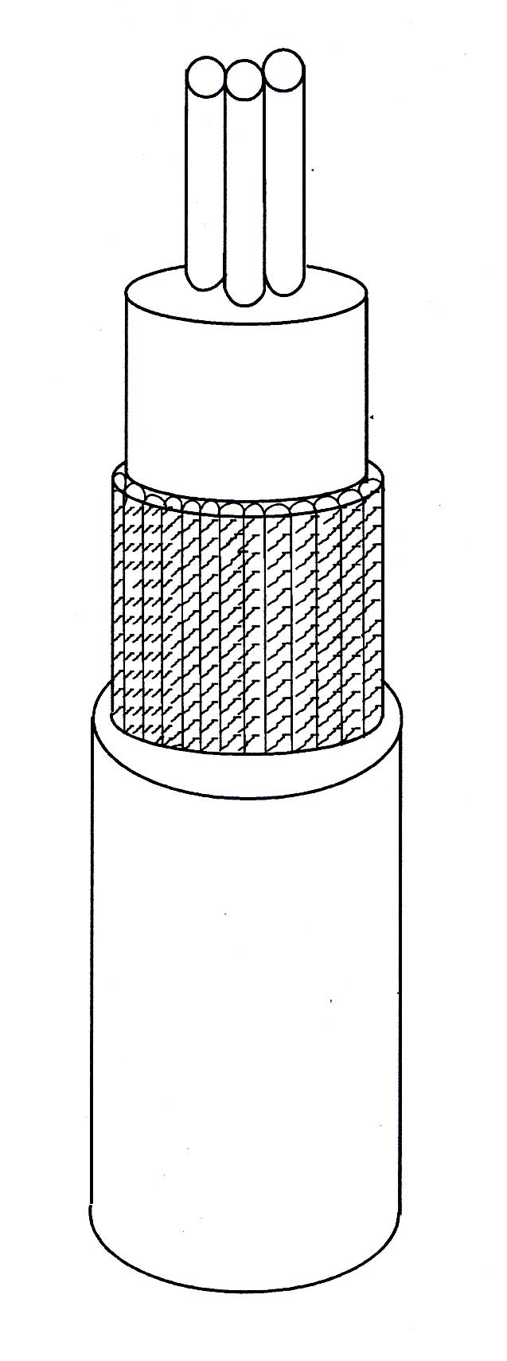
Structural Drawing (1)
Cable conductor
PVC sheath
Armouring steel wire
High pressure PE sheath

Instructions of digital temperature measurement cable for silo
- It is used for the large scaled brick, cement and steel plate silo, and it is convenient for the matching of computers.
- Installation method: hanging from the ceiling of the silo vertically, fix it with chuck or U shaped screw, chucking the inner and outer sheathes are strictly prohibited. The stress of cable wires shall be even.
- Main parameter: the cable conductor has three cores, the armouring steel wire is the multiple stranded wire, the conductor of temperature measurement cable is made in tinned copper wire, whose corrosion resistance is strong, the strength of temperature measurement cable applies armouring steel wire, and the strength is decided according to the height of the silo.
- Temperature measurement component with the model No. DS18B20 shall be welded on the conductor; the space between temperature measurement points shall be located as required.
- The model No. of cable is WVY 32, the inner sheath uses PVC, and the outer sheath applies high pressure polyethylene.

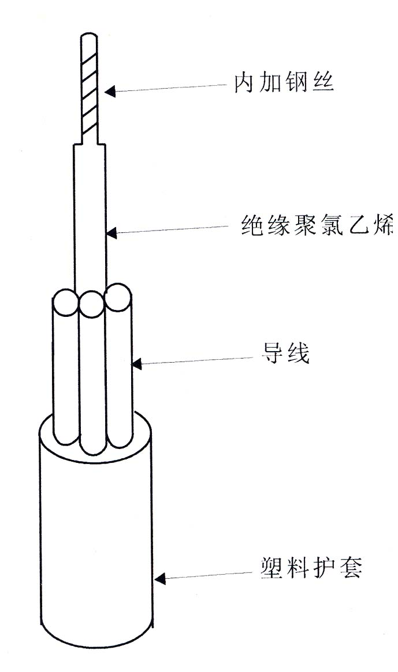
Structural Drawing (2)

Inner steel wire
Insulation PVC
Conductor
Plastic sheath

Temperature measurement cable for horizontal bin is (light-duty digital temperature measurement cable)

- This product is applicable to the temperature measurement of horizontal bin, squat bin and stack. Set the temperature measurement points in flat or interlude ways as required. It can also be used as the matching device for computer and meters.
- Specification parameter: Temperature measurement component with the model No. DS18B20 shall be welded on the conductor; the space between temperature measurement points shall be located as required.
- The model numbers of cable are in two types: one is WVV, the outer sheath uses PVC; the other is WVY, the outer sheath uses high pressure polyethylene.
- The strength of cable can be made according to the shape of the granary.

Annex:
Introduction of the Opening Software Platform for Grain Condition Measurement and Control System
For satisfying the requirements of some customers, our company developed the Opening Software Platform for Grain Condition Measurement and Control System through united development with certain university. Now present it as follows:
1.1 About the Opening Software Platform for Grain Condition Measurement and Control System
The opening software platform for grain condition measurement and control system is a system that utilizes modern electronic technology to realize the real time measuring of the factors that affect grain condition, analyzing and judging the data of real time measuring, providing solution suggestions as well as control it for safe grain storing during the process of the grain storage. The system utilizes modern engineering control configuration concept and middle ware technology to establish a consistent software platform for grain condition measurement and control system, which is expandable, reconfigurable, flexible, adaptable and compatible. On this software platform, different hardware manufacturer equipments can be selected dynamically. The system platform sends out the monitoring and measuring instruction to various hardware platforms of measurement and control system for grain condition which can deliver grain condition data messages that already monitored and measured, and then send out the relevant control signal to the hardware system according to the message. Thereby the difference from various systems can be shielded upwardly to achieve the interconnection and intercommunication.
This platform is a structure of self-developed system which realizes the component based of system function, so that users could order the modules they need. As the software platform shields the diversity of bottom hardware, it also supplies unified standard interface to the higher layer to realize seamless connection. The unified data format, interface and communication agreement could realize the information sharing, which brings great convenience to management work.
This platform system supports LAN and WAN function, so it can greatly facilitate the inquiry and statistic work carried out by different levels of leaders of the grain storage.
In the grain storage LAN, the system is mainly composed by measurement and control main machine and data inquiry customer-end. Measurement and control main machine is in charge of the inspection and control of grain condition measurement and control equipment, which is generally operated by one computer alone. The data inquiry customer-end can be allocated on several computers of grain storage LAN to facilitate relative leaders and staff to check, analysis and draw statements on the data of grain condition.
1.2 Main function of platform
- Setting up relevant inspection software in a short time for certain granary, which helps customer execute different functions such as granary topological design by simple operations.
- Customer identification, different customers have different operation authority.
- Choose hardware to carry on initialization work of hardware;
- Increase and delete granary and setup information of granary and granary arrangement;
- Real-time inspection for grain condition about temperature measurement, humidity measurement and insects measurement; real-time control for grain condition about grain cooling，ventilation and fumigation;
- Display grain condition by stimulating three-dimensional mode which can display granary temperature in layer and row;
- Grain condition will be printed out in the form of chart and curve. The daily grain condition data will be filed automatically for historic search.
- Web grain condition inquiry and analysis service: this service can provide safe, fast and high efficiency WAN web remote services for China Grain Reverse Corporation, such as check the remote volumetric data of grain condition, print the grain condition reports, check the temperature curve of grain condition and so on.
- Customer-end service of measurement and control system platform for grain condition: this service can provide various functions for users within the scope of LAN, such as remote data inquiry of grain condition, volumetric display of grain condition data, preview and printing of grain condition reports, curve inquiry and printing of grain condition and so on.
- Short message service of grain condition measurement and control system platform: this service can provide the remote grain condition inquiry function by short message of mobile phones, which returns the analytical data of grain condition according to the short messages sent by registered customer.
  - Provide stored-grain insects control database for granary workers for them to check and study.

Design Proposal of LZWS-200 Wireless Digital Grain Condition Measurement & Control System to be installed in 5 Granaries of Beijing Niulanshan Grain Granary

The construction and installation of this grain condition measurement and control system for horizontal bin refers to the construction standard of grain depot directly under the central government, and is executed according to the sensor arrangement principle in Grain Trade Standard of People’s Republic of China LS/1203-2002 enacted on May 13, 2002. The system completely conforms to the requirement of Technology Regulation on Grain Condition Electric Monitoring and Analysis Control System established by China Grain Reserves Corporation.
The specific solution combined with attached drawings is as follows:
I. Temperature Measurement Equipment Distribution
There are 4 A granaries separated into 8 sub-granaries; each granary is 59.5m long and 29.2m wide. The grain surface is 6m high. Each sub-granary has 13 groups of temperature measurement cables, 7 cables for each group and 4 temperature measurement points for each cable. There are 91 cables and 364 temperature measurement points in each granary.
There is 1 B granary; this granary is 41.7m long and 17.7 meters wide. The grain surface is 5m high. The granary has 10 groups temperature measurement cables, 5 cables for each group and 4 temperature measurement points for each cable. There are 50 cables and 200 temperature measurement points in this granary.
II. Equipment Allocation and Installation
One granary uses one main machine and one matched set. One extension, one transmitter, one distribution box and one antenna, which are fixed on the wall out of the granary, are used to each sub-granary in granary A. 7 front-end processors and one set of humiture sensor of granary are fixed on the wall in each sub-granary. The granary B has one granary, which uses one extension, one transmitter, one distribution box and one antenna. The whole granary uses 4 front-end processors and one humiture sensor. The installation method is same as above.
The measurement and control main machine and the antenna as well as the computer are put in the control room.
III. Connection of cables: The measurement and control main machine connects with the computer in the 485 mode. The main machine uses wireless transmitter to transmit with extension. The connection between extension and front-end processors and the connection among front-end processors are connected by 4-core communication cables.
Note: This system applies digital temperature sensor produced by American DALLAS company（model DS18B20）.
The complete set of equipment applied the type of full sealing, which has the functions of thunder resistant, fumigating proof and anti-corrosion.
Please see Figure 1, Figure 2, Figure 3 and Figure 4 in detail.

Langfang Zhonggu Grain Protection Equipment Co., Ltd.
Dec.1st, 2007

